Save and share the reports

Reports are created whenever you save a search. After you create a report, you can do a lot with it.

1. Set the time range to **Last 7 days** and run the following search.

This is the same search that you ran in the section [Search with field lookups](http://docs.splunk.com/Documentation/Splunk/6.6.1/SearchTutorial/Searchwithfieldlookups).

sourcetype=access_* status=200 action=purchase [search sourcetype=access_* status=200 action=purchase | top limit=1 clientip | table clientip] | stats count AS "Total Purchased", dc(productId) AS "Total Products", values(productName) AS "Product Names" BY clientip | rename clientip AS "VIP Customer"

**Note:** If your search does not return results, increase the time range of the search. For example, you can run search over the time range **Last 30 days** or **All Time**.

1. Above the Search bar, click **Save as** and select **Report**.

[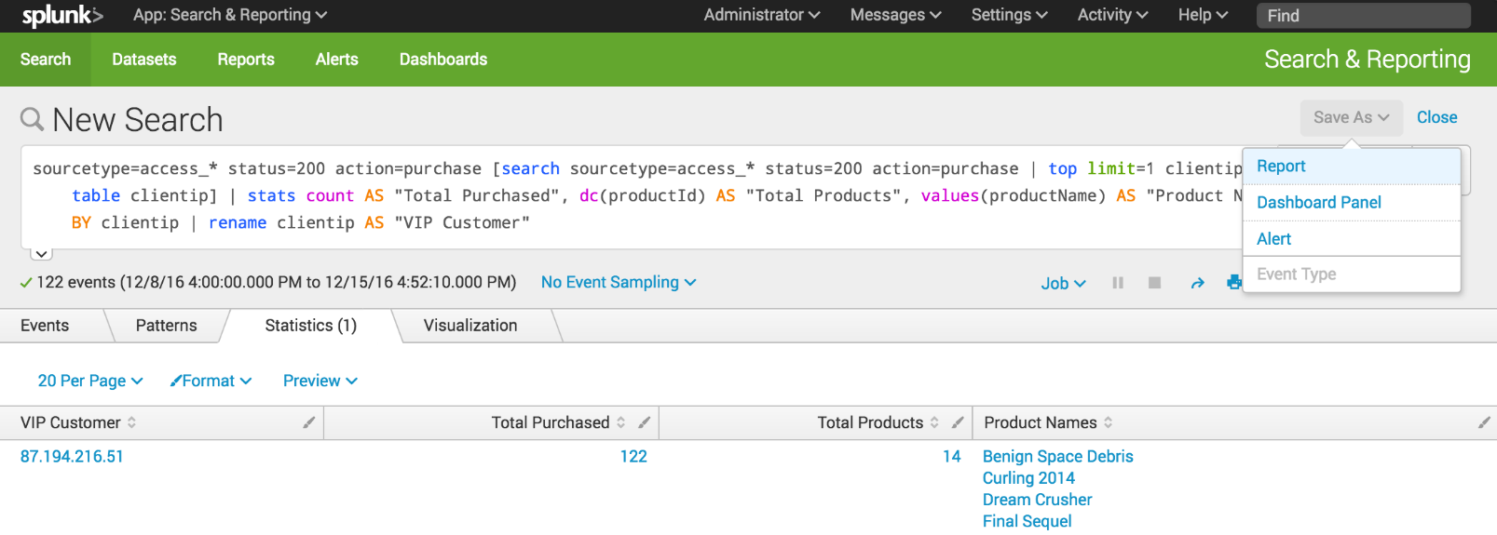](http://docs.splunk.com/File:6.5.1216_tutorial_savereport.png)

1. In the Save As Report dialog box for **Title** type **VIP Customer**.
2. For **Description**, type **Buttercup Games most frequent shopper**.

[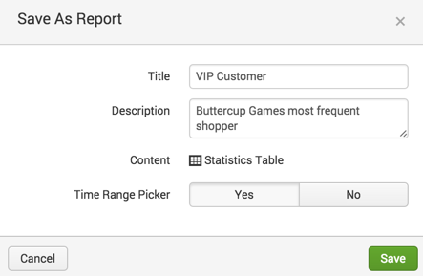](http://docs.splunk.com/File:6.4_tutorial_savereport2.png)

1. For **Time Range Picker**, click **Yes**.

When you include a Time range picker in a report, it gives you the option of running the report with a different time range.

1. Click **Save**.

A confirmation dialog box opens confirming that your report has been created. From this dialog box you can perform the following actions.

* + **Continue Editing**. To refine the search and report format.
  + **Add to Dashboard**. To add the report to a new or existing dashboard.
  + **View**. To view the report.

1. Click **View.**

[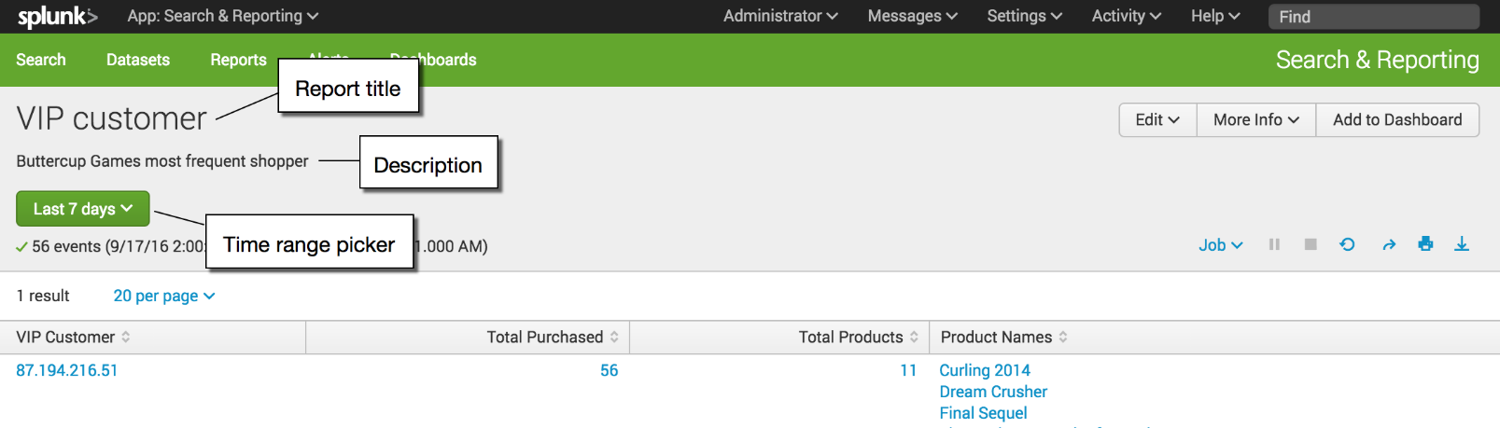](http://docs.splunk.com/File:6.5.0_tutorial_savedreport_view.png)

The title and description that you specified appear at the top of the report. Time range picker is also included at the top of the report. If you specified some other time range for the search, that time range appears in the report.

View and edit reports

You can view and edit reports that you have saved. You edit a report directly from within the report.

1. In the VIP Customer report, click **Edit**.

[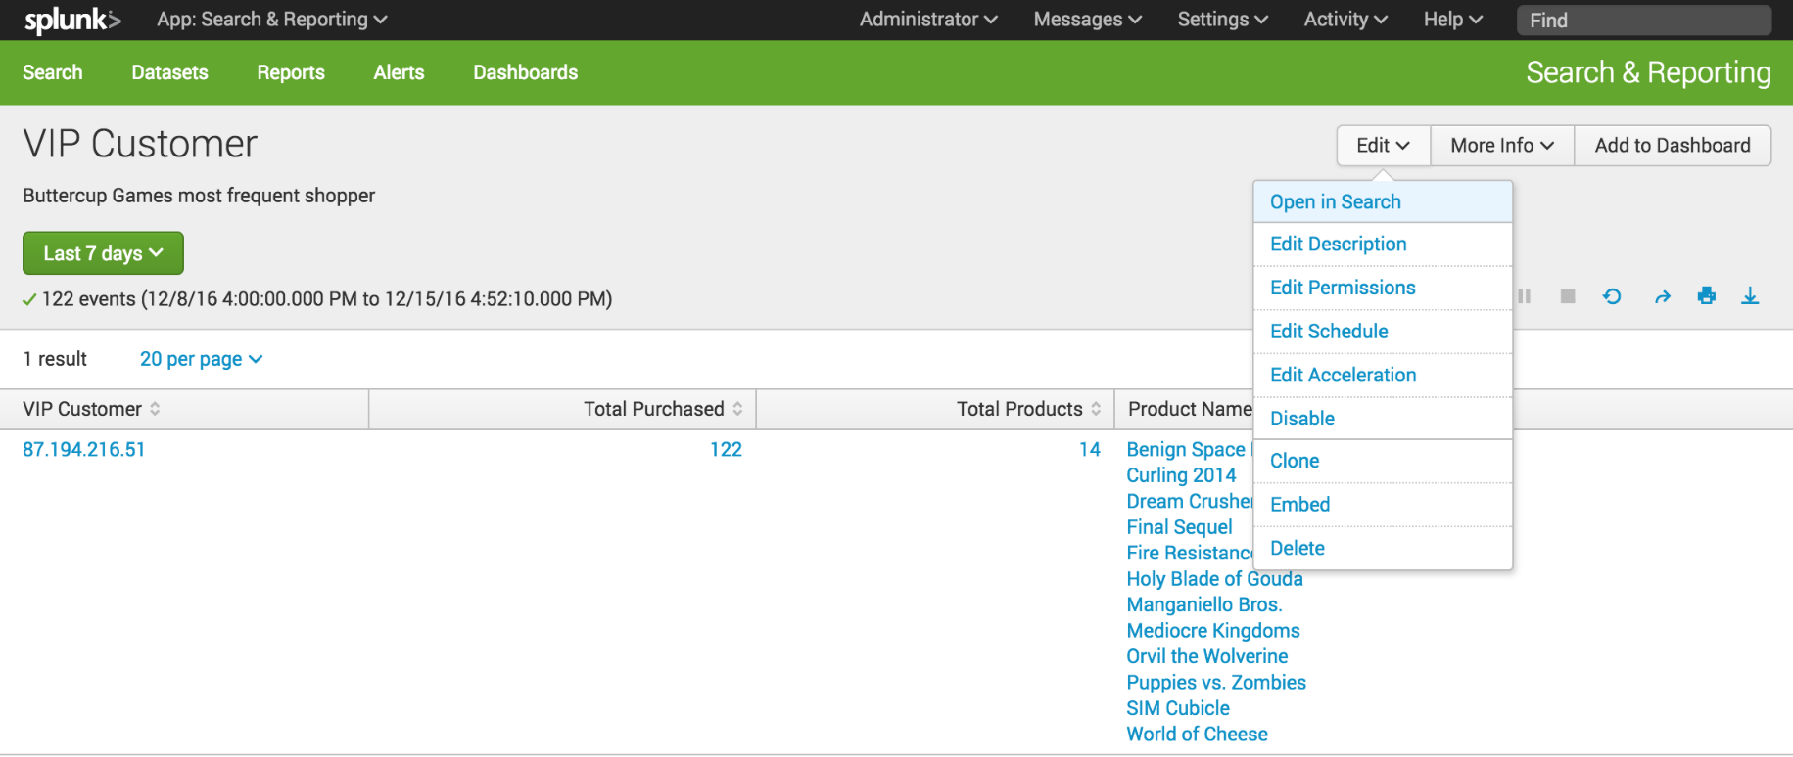](http://docs.splunk.com/File:6.5.1216_tutorial_report_edit.png)

The options are to open the report in the Search view, or to edit the report description, permissions, schedule, and acceleration. You can also clone, embed, and delete the report from this menu.

1. Click **More Info** to view information about the report.

[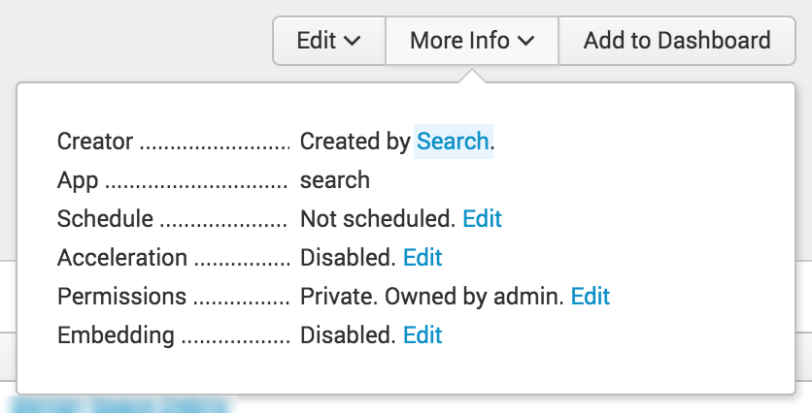](http://docs.splunk.com/File:6.5.0_tutorial_report_moreinfo.png)

From the **More Info** menu, you can view and edit different properties of the report, including its schedule, acceleration, permissions, and embedding.

1. Look at the time range picker, located at the upper left corner of the window.

With the Time range picker, you can change the time period to run this search. For example, you can use this time range picker to run this search for the VIP Customer **Week to date**, **Last 60 minutes**, or **Last 24 hours** just by selecting the Preset time range or defining a custom time range.

[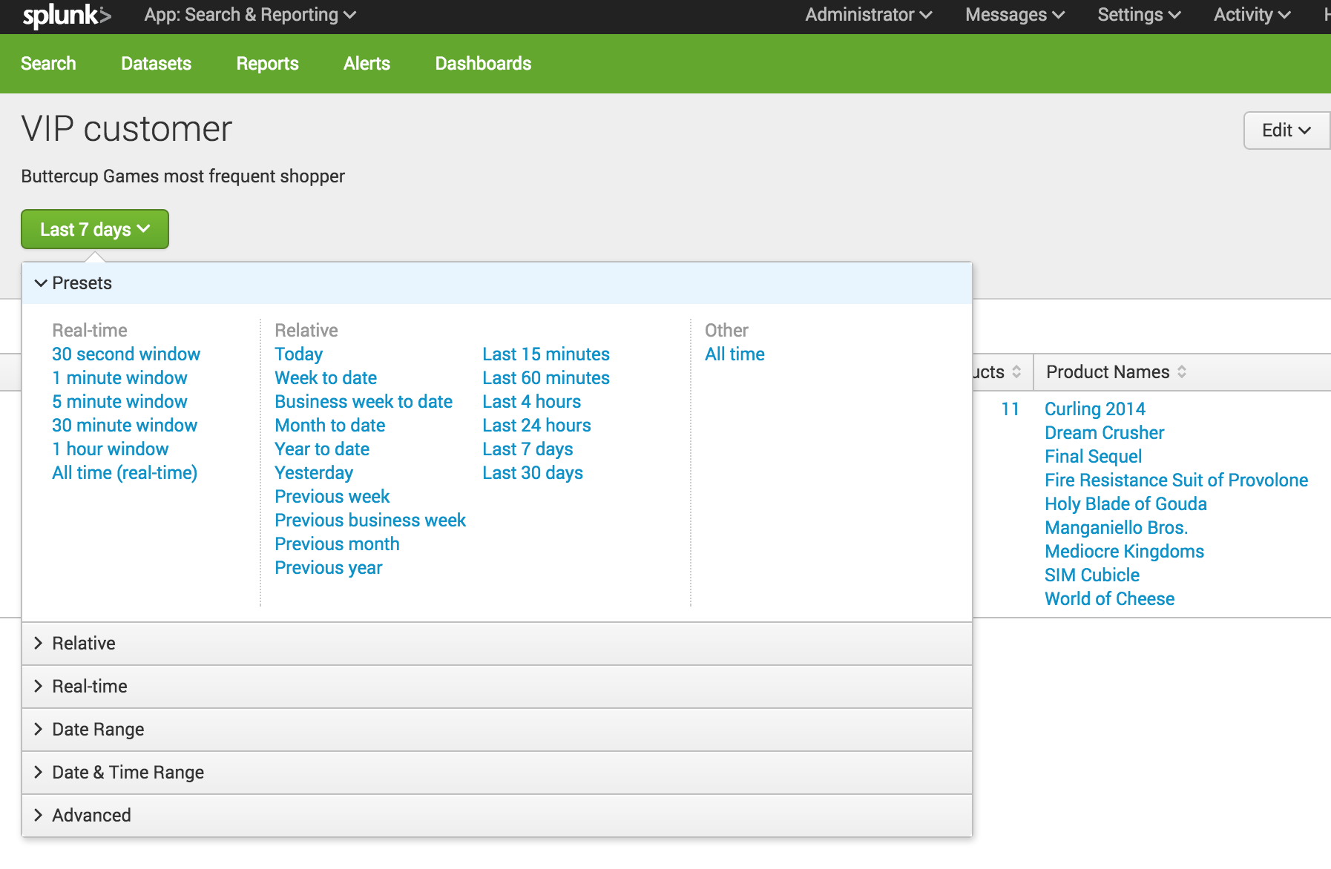](http://docs.splunk.com/File:6.5.0_tutorial_timerange_reportview.png)

Find and share reports

You can access your reports using the App bar.

1. Click **Reports** to open the Reports page and view the list of reports.

[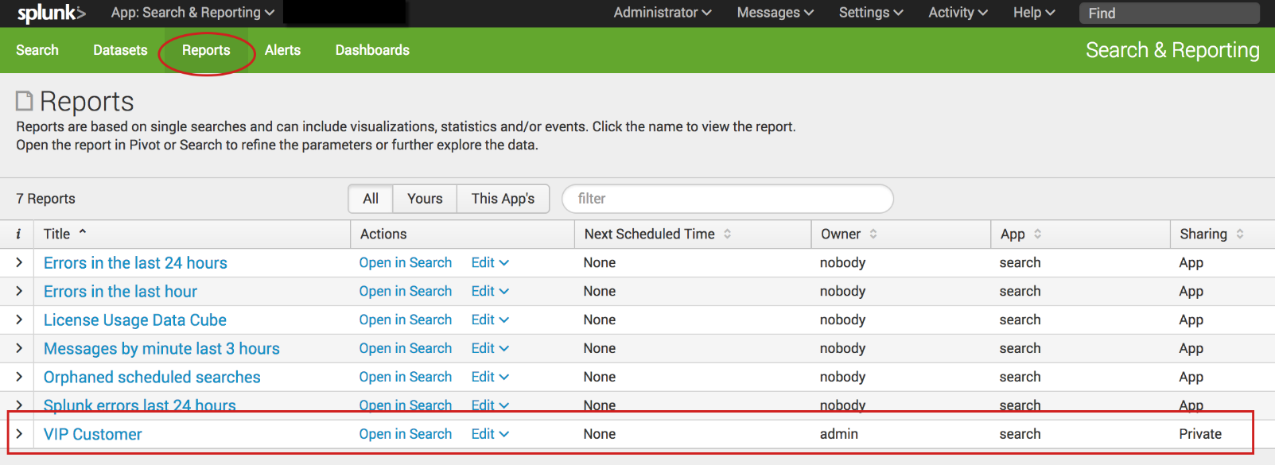](http://docs.splunk.com/File:6.6.0_tutorial_reportslist.png)

When you save a report, **Sharing** is set to **Private**. Only you can view and edit the report. You can allow other apps to view, edit, or both view and edit the report by changing the report permission.

1. For the **VIP Customer** report, under **Actions** click **Edit**.
2. Select **Edit Permissions**.

[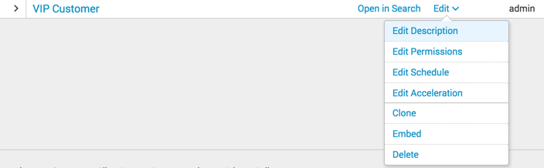](http://docs.splunk.com/File:6.4_tutorial_report_editpermissions.png)

1. In the Edit Permissions dialog box, set **Display For** to **App**.

The display expands to show more settings.

1. For **Everyone**, mark the check box under **Read**.

[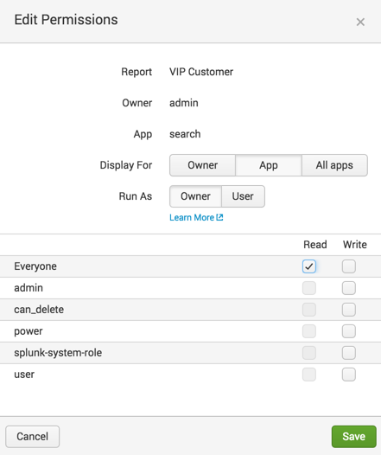](http://docs.splunk.com/File:6.4_tutorial_report_editpermissions2.png)

This action gives everyone who has access to this app the permission to view the report.

1. Click **Save**.

The Reports page appears. The **Sharing** setting for the VIP Customer report now reads **App** instead of Private.

[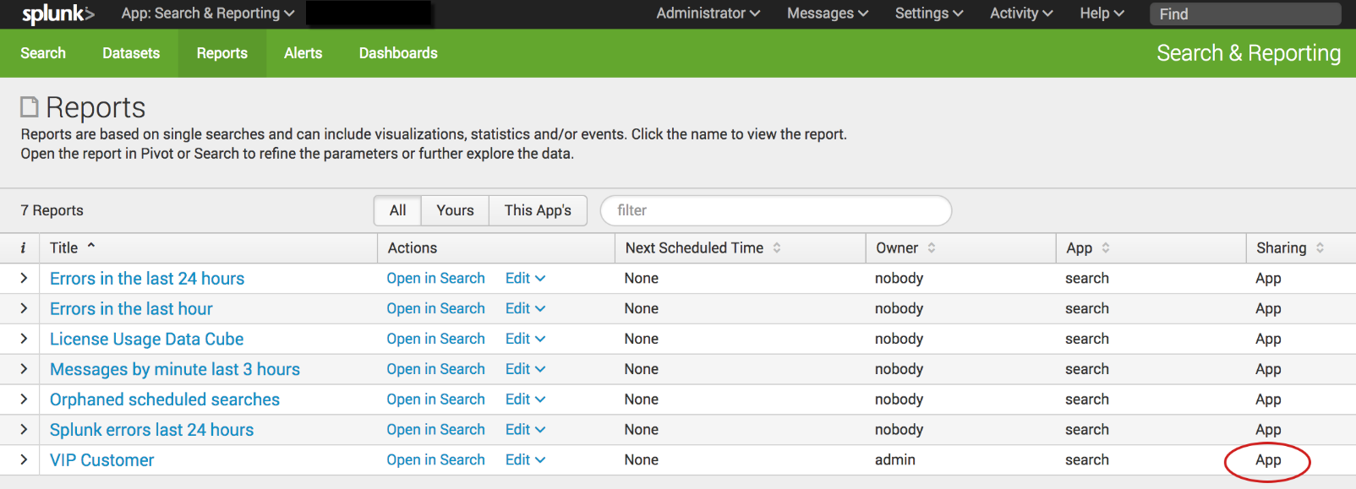](http://docs.splunk.com/File:6.6.0_tutorial_report_changedpermissions.png)

Search , chart and report Examples

Example: Compare counts of user actions

In this example you will calculate information about the actions customers have taken on the online store website.

* The number of times each product is viewed
* The number of times each product is added to the cart
* The number of times each product is purchased

**Prerequisite**   
This example uses the productName field from the prices_lookup that you created in the [Enabling field lookups](http://docs.splunk.com/Documentation/Splunk/6.6.1/SearchTutorial/Usefieldlookups) section in this tutorial. You must complete all of those steps in that section before continuing with this example.

**Steps**

1. Start a new search.
2. Set the time range to **All time**.
3. Run the following search.

sourcetype=access_* status=200 | chart count AS views count(eval(action="addtocart")) AS addtocart count(eval(action="purchase")) AS purchases by productName | rename productName AS "Product Name", views AS "Views", addtocart AS "Adds to Cart", purchases AS "Purchases"

This search uses the chart command to count the number of events that are action=purchase and action=addtocart. The search then uses the rename command to rename the fields that appear in the results.

The chart command is a transforming command. The results of the search appear on the **Statistics** tab.

[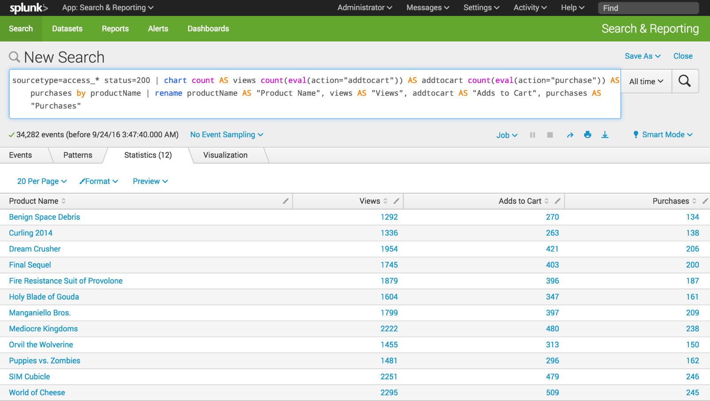](http://docs.splunk.com/File:6.5.0_tutorial_moresearches_ex1.1.png)

1. Click the **Visualization** tab. The search results appear in a Pie chart.
2. Change the display to a **Column** chart.

[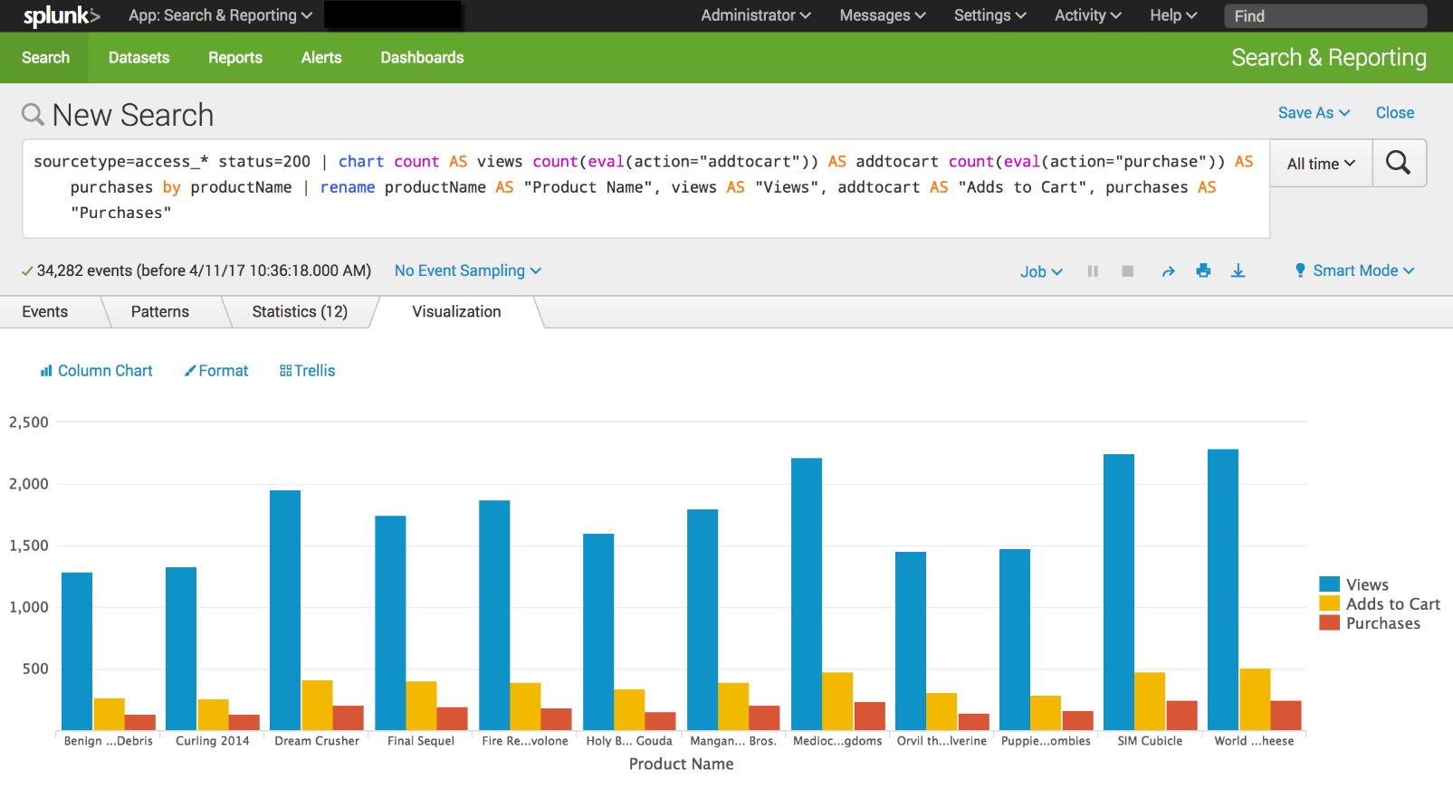](http://docs.splunk.com/File:6.6.0_tutorial_moresearches_ex1.2.png)

Example: Overlay Actions and Conversion Rates on one chart

In this example, you will use the stats command to count the user actions. The eval command is used to calculate the conversion rates for those actions. For example, how often someone who viewed a product added the product to their cart.

**Prerequisite**   
This example uses the productName field from the prices_lookup that you created in the [Enabling field lookups](http://docs.splunk.com/Documentation/Splunk/6.6.1/SearchTutorial/Usefieldlookups)  You must complete all of those steps in that section before continuing with this example.

**Steps**

1. Start a new search.
2. Change the time range to **All time**.
3. Run the following search.

sourcetype=access_* status=200 | stats count AS views count(eval(action="addtocart")) AS addtocart count(eval(action="purchase")) AS purchases by productName | eval viewsToPurchases=(purchases/views)*100 | eval cartToPurchases=(purchases/addtocart)*100 | table productName views addtocart purchases viewsToPurchases cartToPurchases | rename productName AS "Product Name", views AS "Views", addtocart as "Adds To Cart", purchases AS "Purchases"

The eval command is used to define two new fields. These fields contain the conversion rates.

* + The **viewToPurchases** field calculates the number of customers who viewed the product to the number of customers who purchased the product. The calculation returns a percentage.
  + The **cartToPurchases** field calculates the number of customers who added the product to their cart to the number of customers who purchased the product. The calculation returns a percentage.

[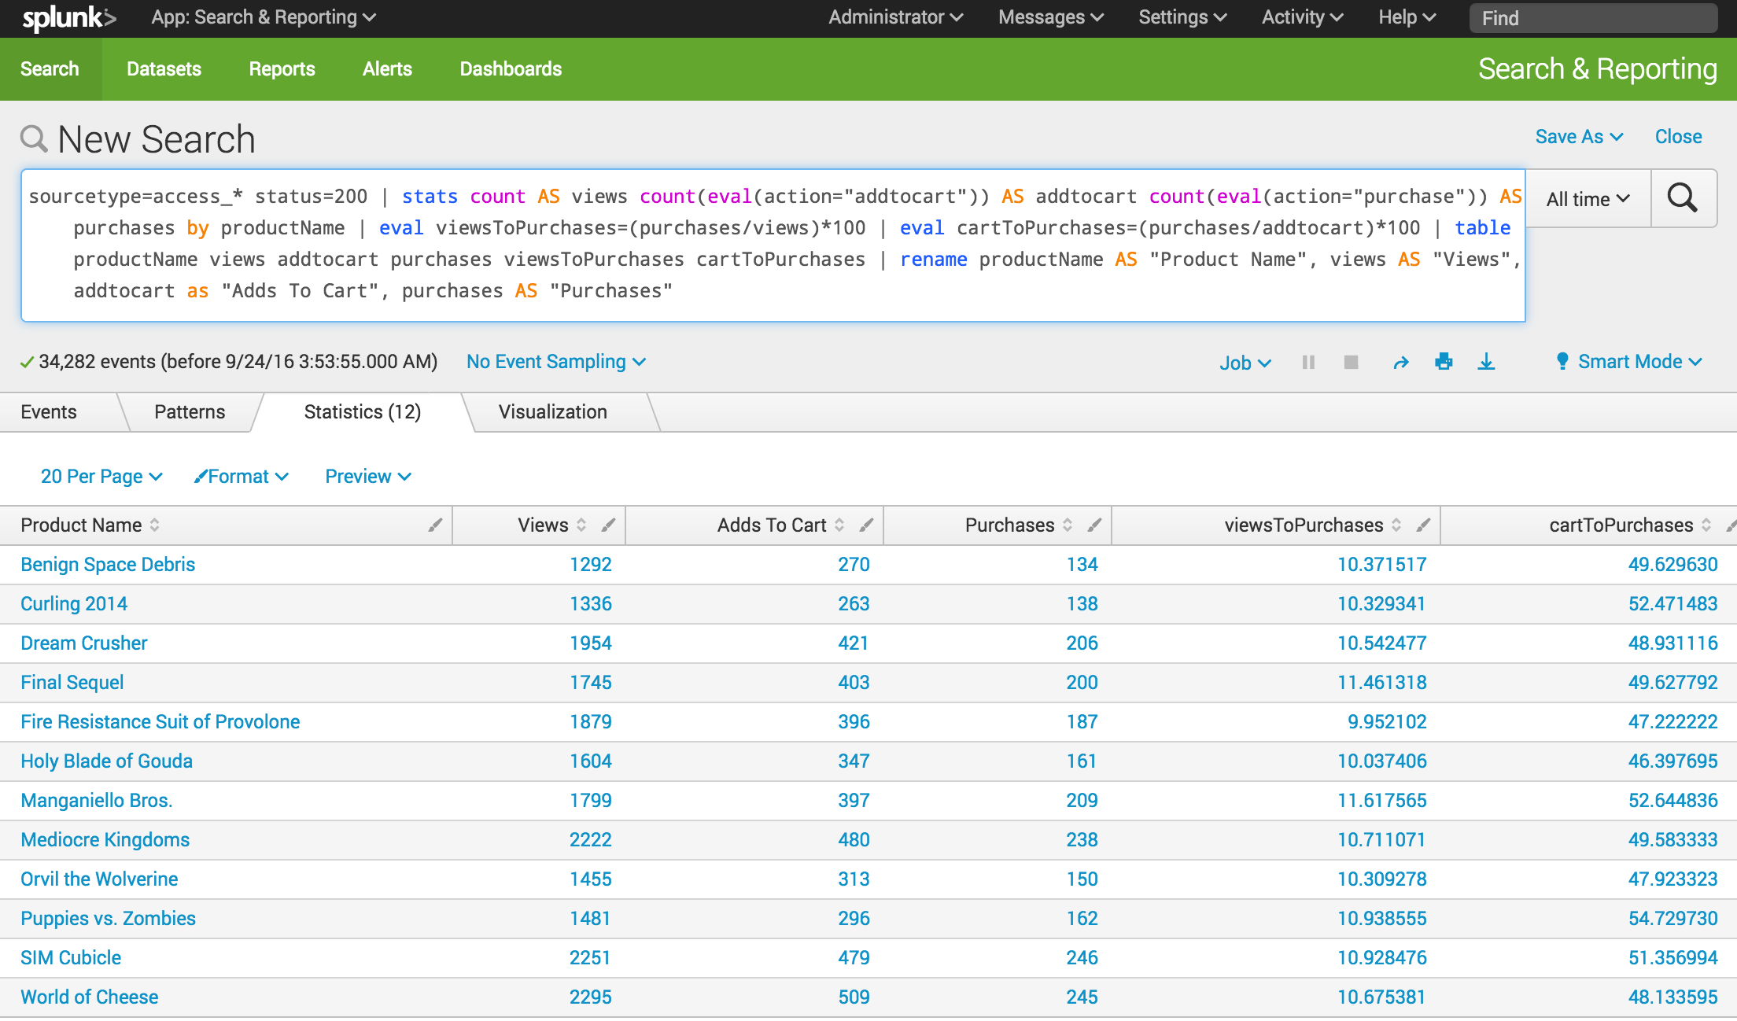](http://docs.splunk.com/File:6.5.0_tutorial_moresearches_ex2.1.png)

The next few steps reformat the chart visualization to overlay the two data series for the conversion rates, onto the three data series for the actions.

1. Click the **Visualization** tab.

This is the same chart as in Example 1, with two additional data series, **viewsToPurchase** and **cartToPurchase**.

[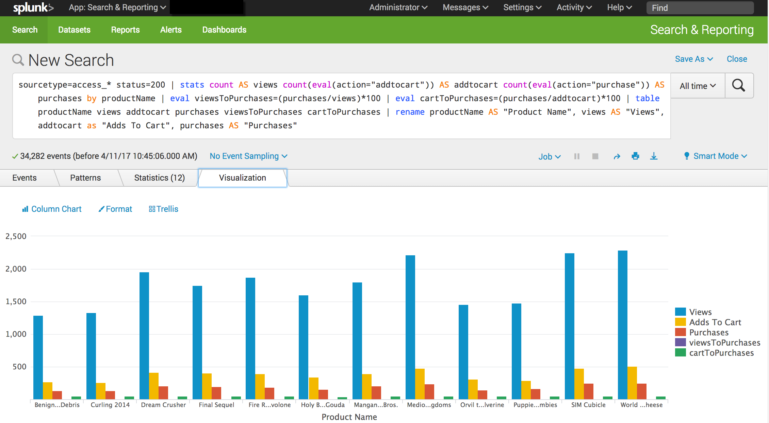](http://docs.splunk.com/File:6.6.0_tutorial_moresearches_ex2.2.png)

1. Click **Format** and **X-Axis**.

Because the labels on the X-Axis are difficult to read, let's fix that.

[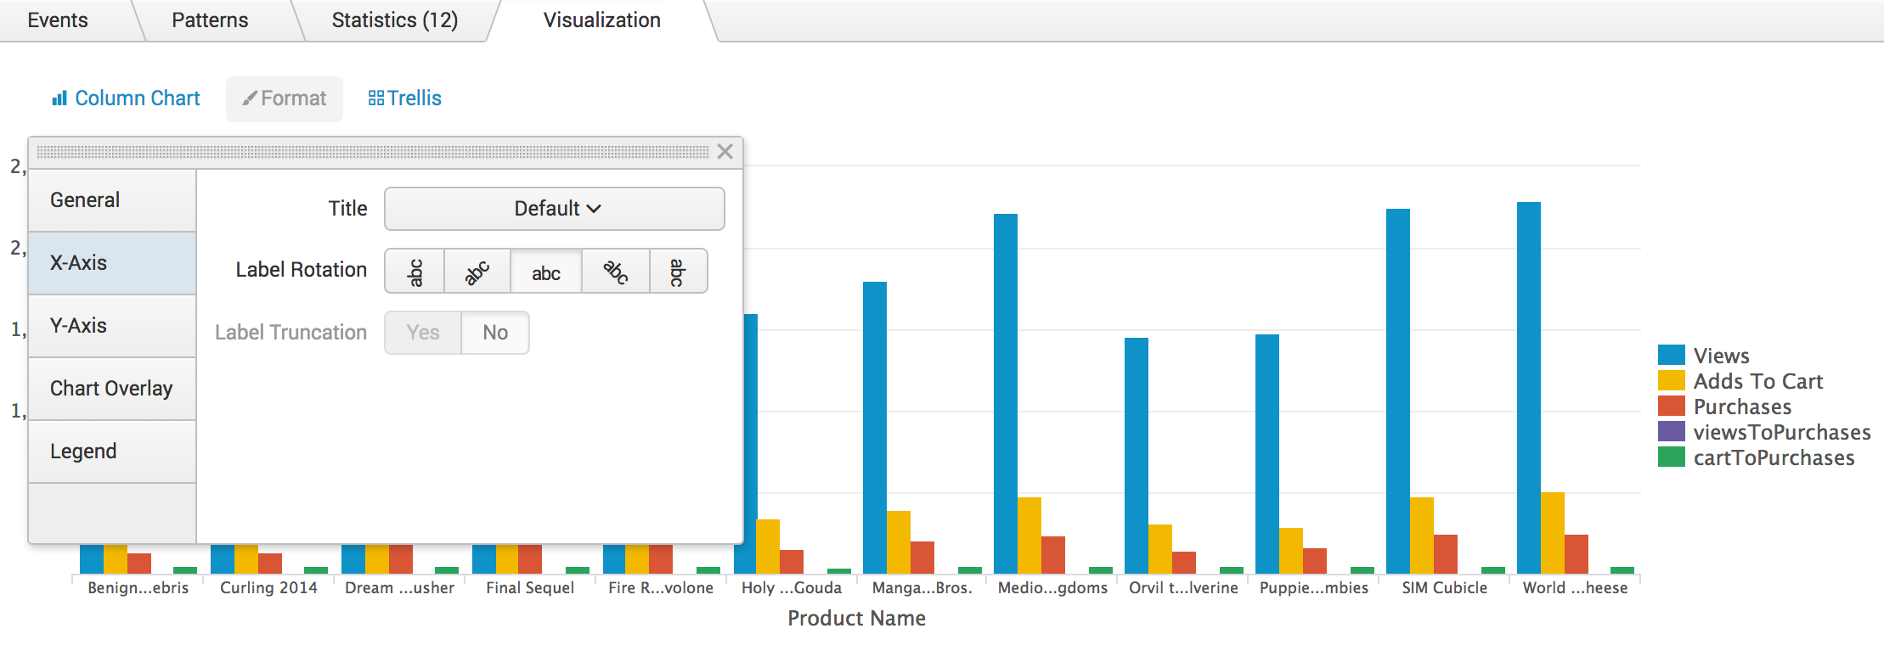](http://docs.splunk.com/File:6.6.0_tutorial_moresearches_ex2.3.png)

* + Rotate the label **-45** degrees.
  + Close the Format dialog box.

Notice the change in the labels on the X-Axis. Look at the numbers on the Y-Axis. They range from 1000 to 3000.

1. Click **Format** and **Y-Axis**.

To make the chart easier to read, add a label and specify different number intervals on the Y-Axis.

* + For **Title**, choose **Custom** and type **Actions**.
  + For **Interval** type **500**.
  + For **Max Value** type **2500**.

[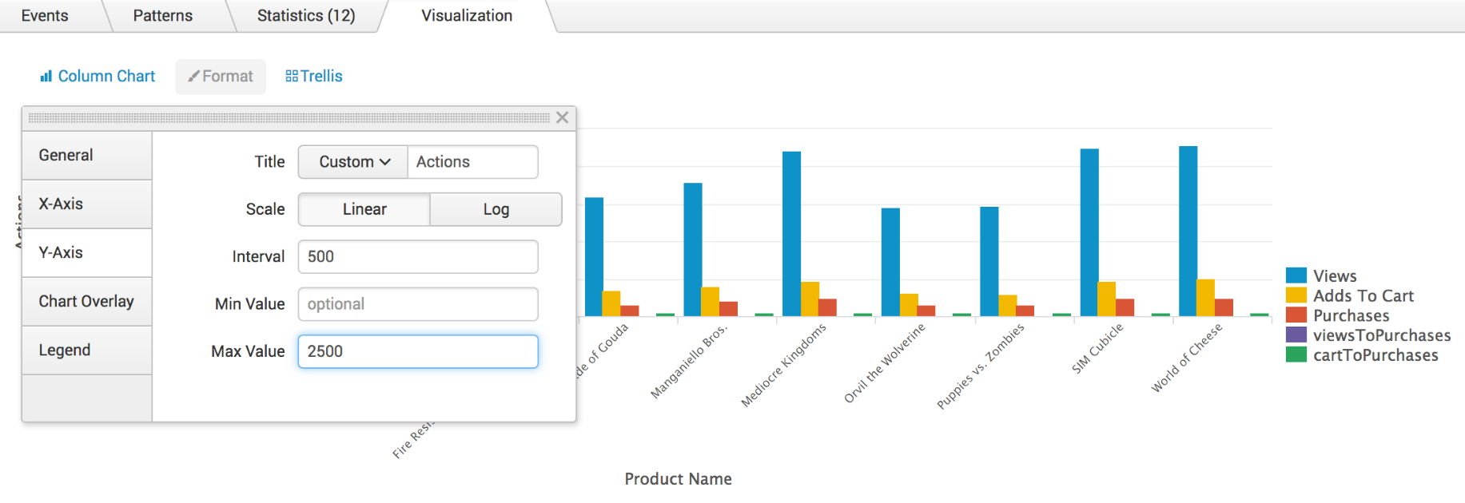](http://docs.splunk.com/File:6.6.0_tutorial_moresearches_ex2.4.png)

* + Close the Format dialog box. Notice the label and values on the Y-Axis.

1. Click **Format** and **Chart Overlay**.

To separate the actions (views, adds to cart, and purchases) from the conversion rates (viewToPurchases and cartToPurchases), you can overly one set of values over another set. In this example you will overlay the conversion rates over the actions.

* + For **Overlay**, click inside the box and select **viewsToPurchase**. Click inside the box again and select **cartToPurchase**.
  + For **View as Axis**, click **On**.
  + For **Title**, choose **Custom**

[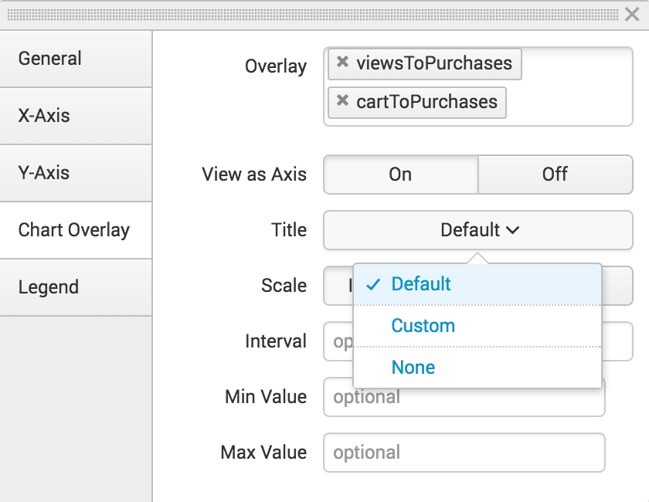](http://docs.splunk.com/File:6.5.0_tutorial_moresearches_ex2.5.png)

* + Type **Conversion Rates**.
  + For **Scale**, click **Linear**.
  + For the **Interval** type **20**. For the **Max Value** type **100**.

[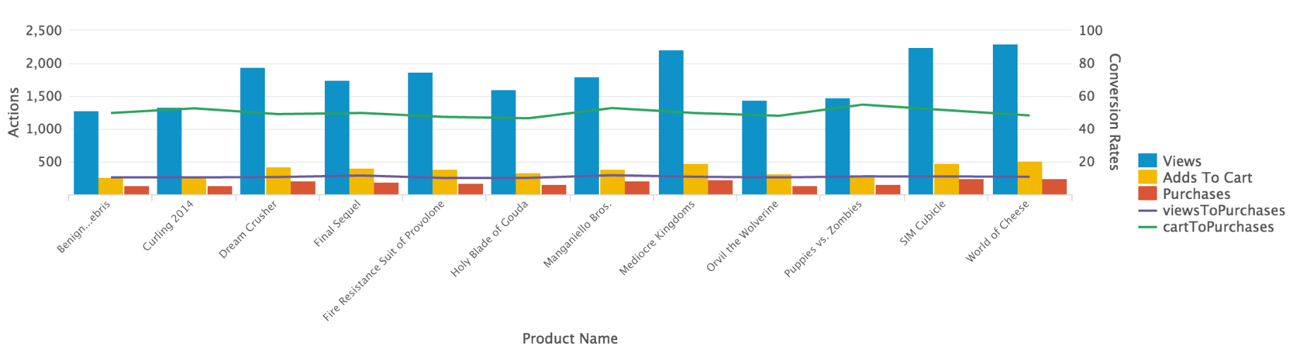](http://docs.splunk.com/File:6.5.0_tutorial_moresearches_ex2.6.png)

The axis on the right side of the chart is called the **second Y-Axis**. The label and values for the line series appear on this axis.

1. Click **Save As** and select **Report**.

[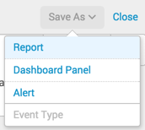](http://docs.splunk.com/File:6.4_tutorial_moresearches_saveAs.png)

* + In the Save Report As dialog box, for **Title** type **Comparison of Actions and Conversion Rates by Product.**
  + For **Description**, type **The number of times a product is viewed, added to cart, and purchased and the rates of purchases from these actions.**

1. Click **Save**
2. In the confirmation dialog box, click **View**.

[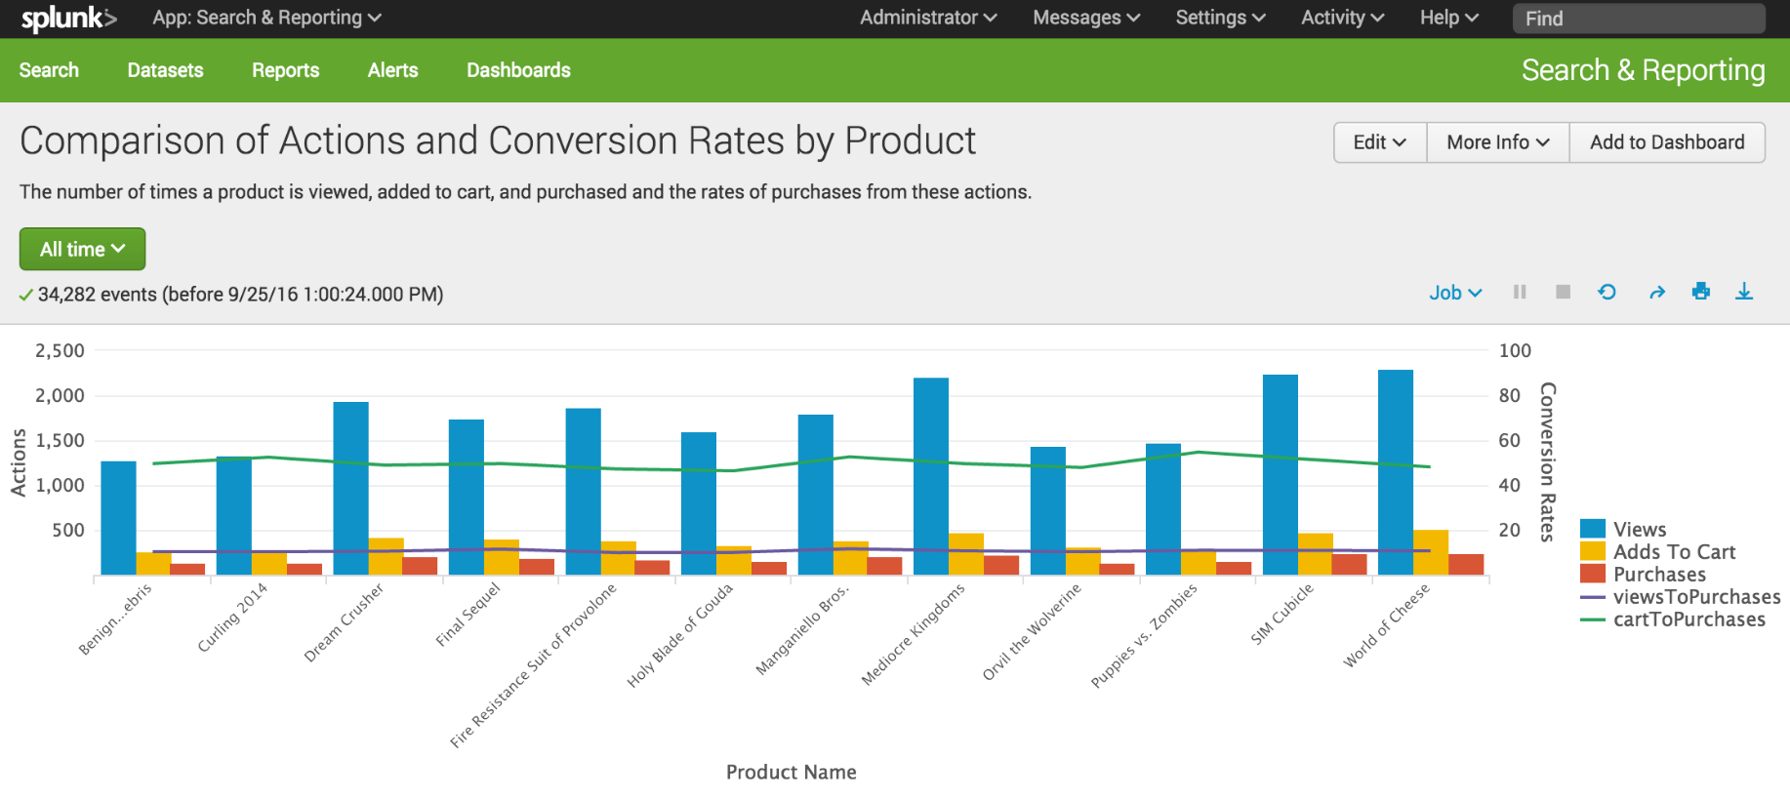](http://docs.splunk.com/File:6.5.0_tutorial_moresearches_ex2.8.png)

Example: Products purchased over time

Create a report that charts the number of purchases that were completed for each item in the last week.

**Prerequisite**   
This example uses the productName field from the prices_lookup that you created in the [Enabling field lookups](http://docs.splunk.com/Documentation/Splunk/6.6.1/SearchTutorial/Usefieldlookups) section of this tutorial. You must complete all of those steps in that section before continuing with this example.

**Steps**

1. Start a new search.
2. Change the time range to **Previous week**.
3. Run the following search.

sourcetype=access_* | timechart count(eval(action="purchase")) by productName usenull=f useother=f

This search uses the count() function to count the number of events that have the field action=purchase.

The search also uses the usenull and useother arguments to ensure that the timechart command only counts events that have a value for productName.

The following table appears on the **Statistics** tab.

[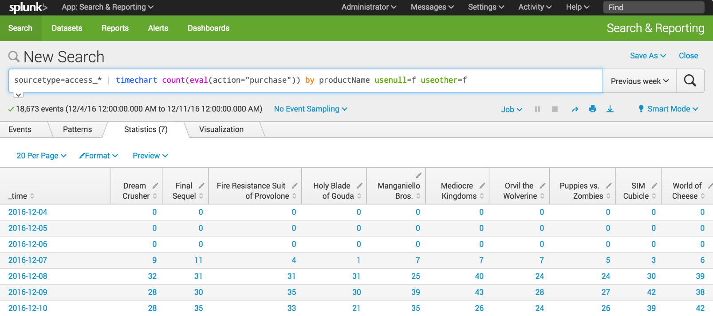](http://docs.splunk.com/File:6.5.1216_tutorial_moresearches_ex3.1.png)

1. Click the **Visualization** tab.
2. Change the chart type to a Line chart.
3. In the **Format** drop-down list, format the **X-Axis**, **Y-Axis**, and **Legend** using the settings in the following table.

|  |  |
| --- | --- |
| **Chart changes** | **Setting or value** |
| Chart type | Line |
| X-Axis CustomTitle | Date |
| X-Axis Labels | -45 degree angle |
| Y-Axis Custom Title | Purchases |
| Y-Axis Interval | 10 |
| Legend Position | Top |

1. The following image shows the updated chart.
2. [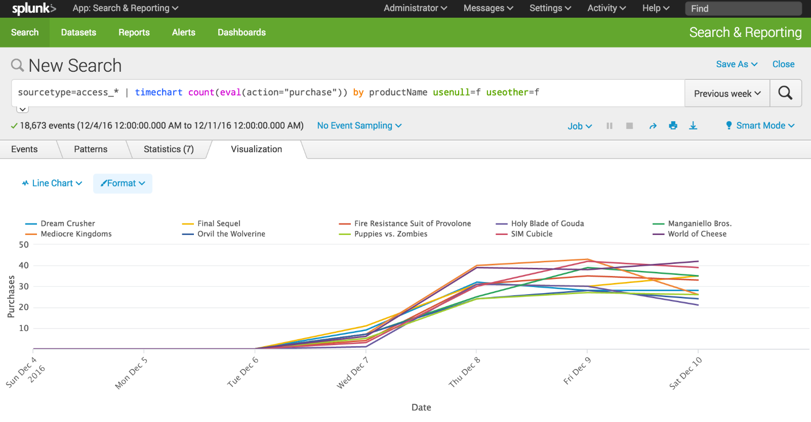](http://docs.splunk.com/File:6.5.1216_tutorial_moresearches_ex3.2.png)
3. Click **Save As** and select **Report**.

[](http://docs.splunk.com/File:6.4_tutorial_moresearches_saveAs.png)

* 1. In the **Save Report As** dialog box, for **Title** type **Product Purchases over Time**.
  2. For **Description**, type **The number of purchases for each product**.
  3. For **Content**, select **Line Chart and Statistics Table**.
  4. For **Time Range Picker**, keep the default setting **Yes**.

1. Click **Save**.
2. In the confirmation dialog box, click **View** to see the report.

[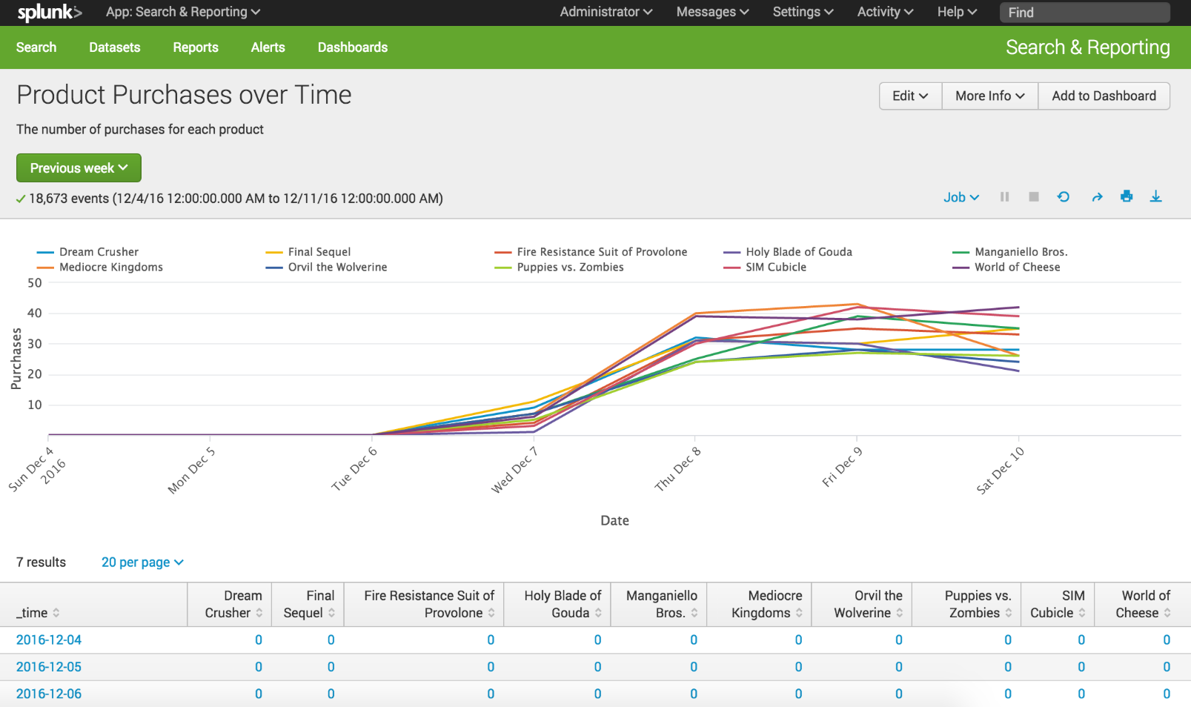](http://docs.splunk.com/File:6.5.1216_tutorial_moresearches_ex3.3.png)

Example: Purchasing trends

This example uses sparkline charts to show trends in the number of purchases made over time.

*Sparklines* are inline charts that appear in the search results table and are designed to display time-based trends associated with the primary key of each row. For searches that use the stats and chart commands, you can add sparkline charts to the results tables.

**Prerequisite**   
This example uses the productName field from the prices_lookup that you created in the [Enabling field lookups](http://docs.splunk.com/Documentation/Splunk/6.6.1/SearchTutorial/Usefieldlookups) section in this tutorial. You must complete all of those steps before continuing with this example.

**Steps**

1. Start a new search.
2. Change the time range to **All time**.
3. Run the following search.

sourcetype=access_* status=200 action=purchase| chart sparkline(count) AS "Purchases Trend" count AS Total by categoryId | rename categoryId AS "Category"

This search uses the chart command to count the number of purchases by using action="purchase". The search specifies the purchases made for each product by using categoryId. The difference is that the count of purchases is now an argument of the sparkline() function.

[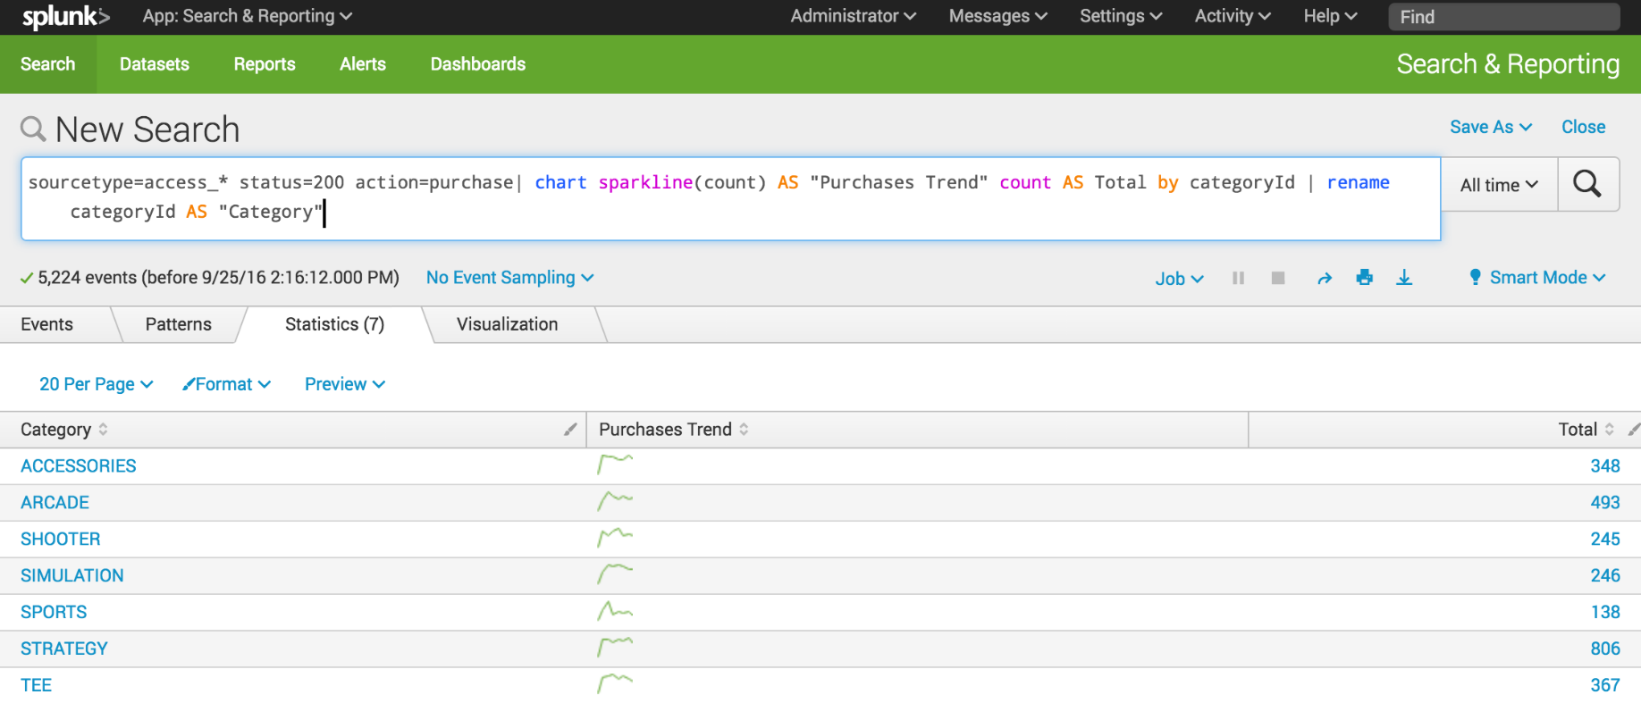](http://docs.splunk.com/File:6.5.0_tutorial_moresearches_ex4.1.png)

1. Click **Save As** and select **Report**.
2. In the **Save Report As** dialog box, for **Title** type **Purchasing trends**.
3. For **Description**, type **Count of purchases with trending**.

[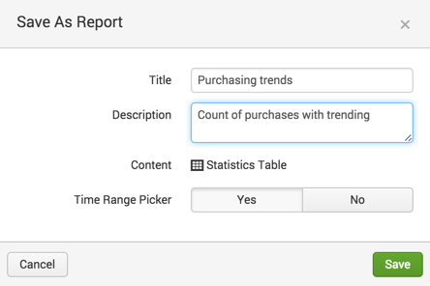](http://docs.splunk.com/File:6.4_tutorial_moresearches_ex4.2.png)

1. Click **Save**.
2. In the confirmation dialog box, click **View**.

[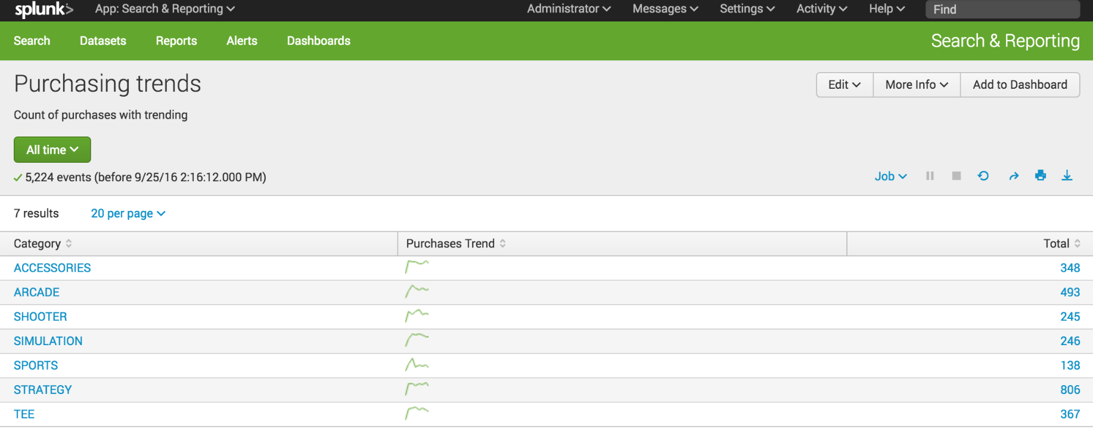](http://docs.splunk.com/File:6.5.0_tutorial_moresearches_ex4.3.png)

Create Dashboard and Panels

Save a search as dashboard panel

1. Start a new search.
2. Change the time range to **Yesterday**.
3. Run the following search.

sourcetype=access_* status=200 action=purchase | top categoryId

If no results are returned, expand your time range to **Previous week**.

[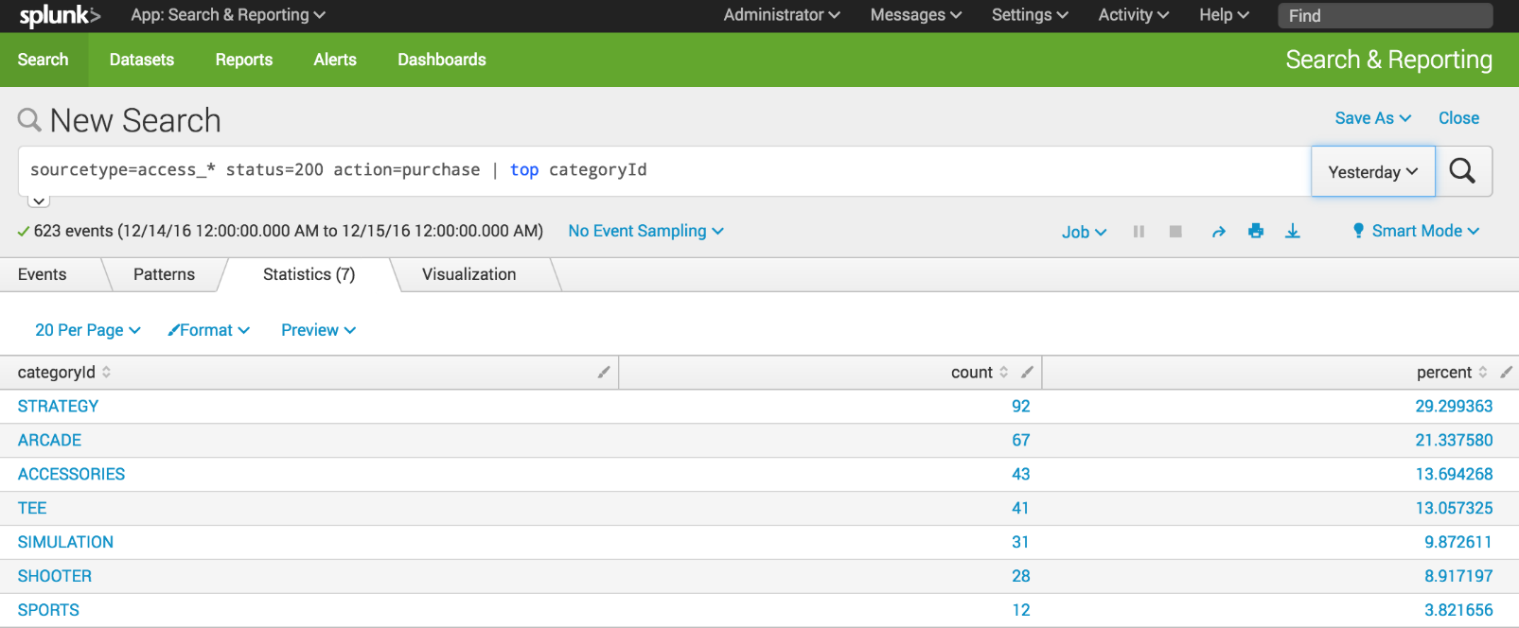](http://docs.splunk.com/File:6.5.1216_tutorial_dashboards1.png)

1. Click the **Visualization** tab. The displays shows a Line Chart.
2. Change the Line Chart to **Pie Chart**.

[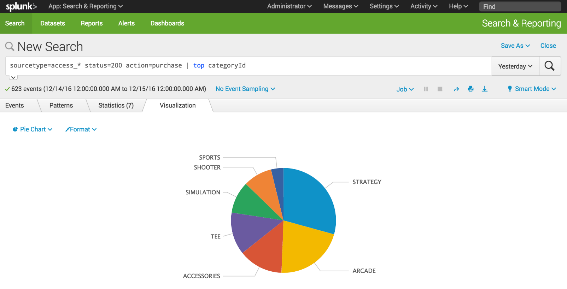](http://docs.splunk.com/File:6.5.1216_tutorial_dashboards2.png)

1. Click **Save As** and select **Dashboard Panel**.
2. Define a new dashboard and dashboard panel.
   1. For **Dashboard**, click **New**.
   2. For **Dashboard Title**, type **Buttercup Games - Purchases**.

The **Dashboard ID** field displays **buttercup_games__purchases**.

* 1. For **Dashboard Description**, type **Reports on Buttercup Games purchases data**.
  2. For **Dashboard Permissions**, keep the default setting **Private**.
  3. For **Panel Title**, type **Top Purchases by Category**.
  4. For **Panel Powered By**, keep the default setting **Inline search**.
  5. For **Panel Content**, keep the setting for **Pie Chart**.

[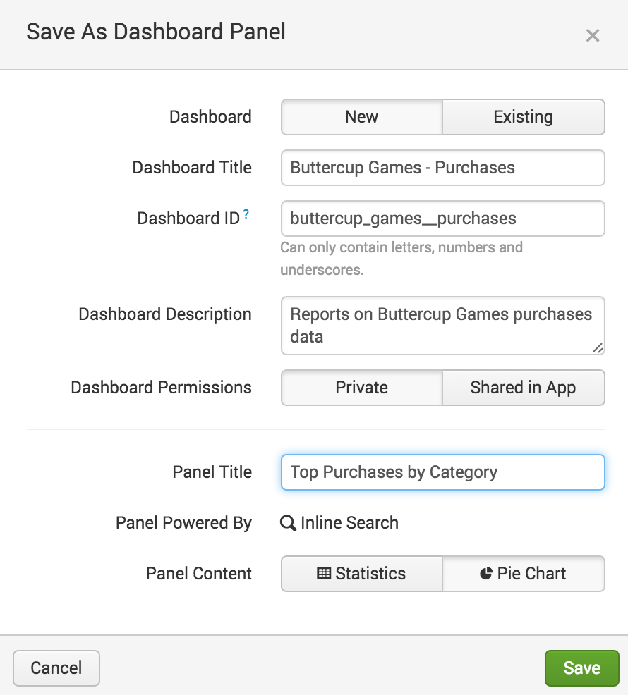](http://docs.splunk.com/File:6.5.0_tutorial_dashboards4.png)

1. Click **Save**.
2. In the confirmation dialog box, click **View Dashboard**.

[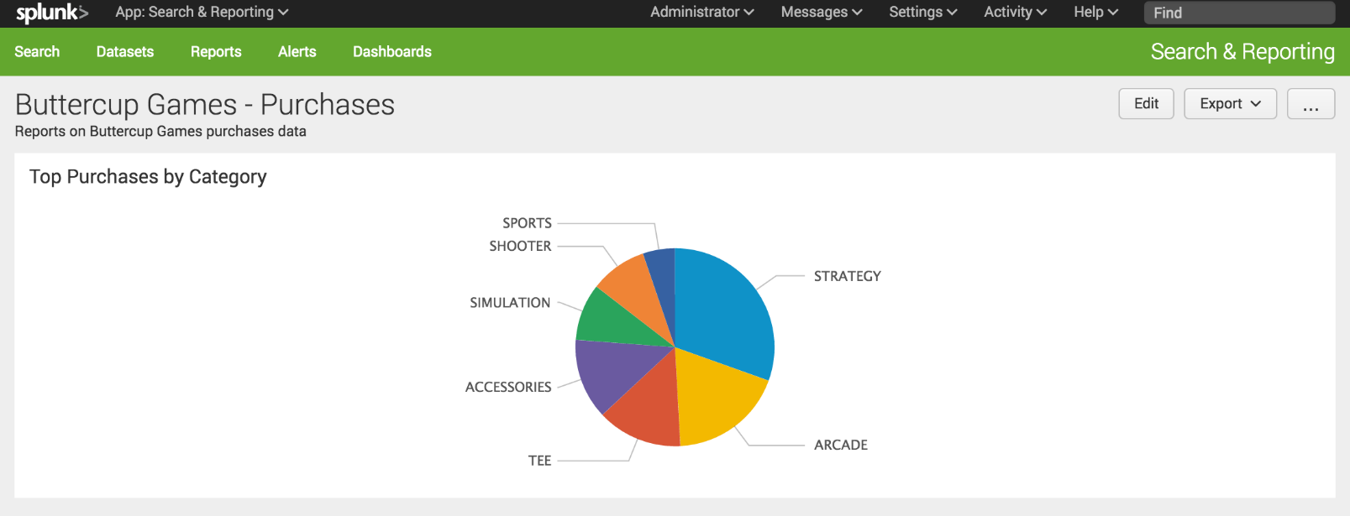](http://docs.splunk.com/File:6.5.0_tutorial_dashboards6.png)

You now have a dashboard with one report panel. To add more report panels, you can either run new searches and save them to this dashboard, or you can add saved reports to this dashboard. You will add more panels to this dashboard in the next section.

For now, let's spend a little bit more time on this dashboard panel.

## View and edit dashboard panels

There is a separate view to see a list of the dashboards that you have access to. From this view, you can create dashboards, and make changes to dashboards and dashboard panels.

1. Click **Dashboards** in the App bar to see the Dashboards view.

You might see a pop-up dialog box asking if you want to take a tour about dashboards. If you take the tour, there is an option at the end of the tour to try dashboards yourself. This option displays the Dashboards view.

In addition to the **Buttercup Games - Purchases** dashboard that you created, there are several built-in dashboards.

[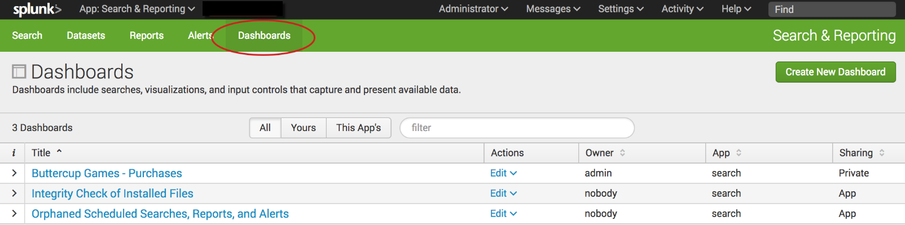](http://docs.splunk.com/File:6.6.0_tutorial_dashboardslist.png)

1. For the **Buttercup Games - Purchases** dashboard, click the arrow ( > ) symbol in the ***i***column to expand the dashboard information.

You can see information about the app that this dashboard is associated with, whether or not the dashboard is scheduled, and the dashboard permissions.

[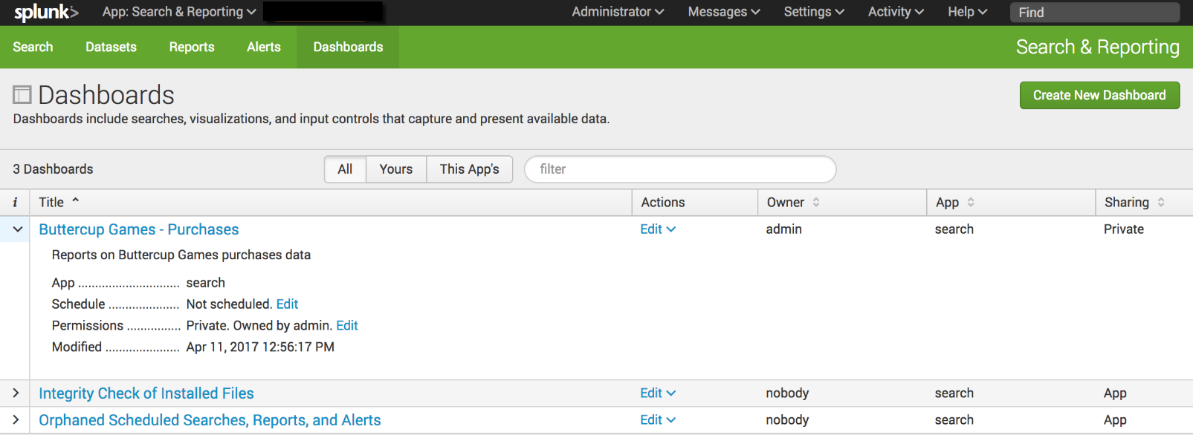](http://docs.splunk.com/File:6.6.0_tutorial_dashboardslistinfo.png)

## Add controls to a dashboard

You can add input controls, such as the Time range picker, to dashboard panels.

1. In the **Dashboards** list, click **Buttercup Games - Purchases** to display that dashboard.
2. Click **Edit**.

[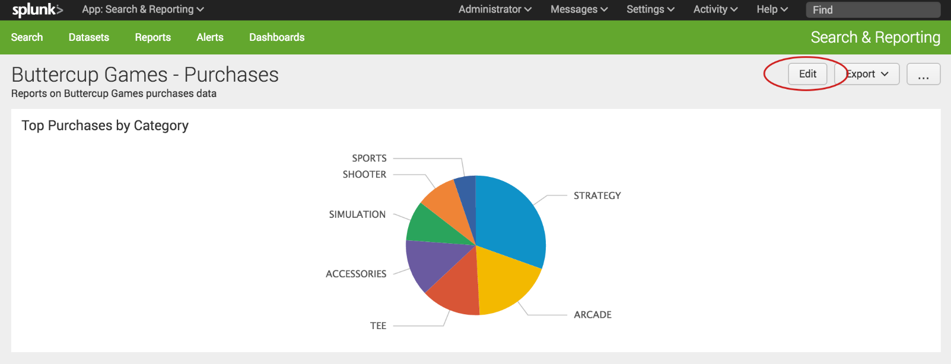](http://docs.splunk.com/File:6.5.0_tutorial_dashboards_edit.png)

You can either edit the dashboard using the UI or the Source. With the UI option you can add panels and inputs to the dashboard.

* + Use the **Add Panel** option to create a new panel, add a report as a panel, or clone from an existing dashboard.
  + Use the **Add Input** option to choose from a list of controls to add to the dashboard, including text, a checkbox, and a time range picker.

With the Source option, you can edit the XML source for the panel directly. Editing the source directly is not discussed in this tutorial.

[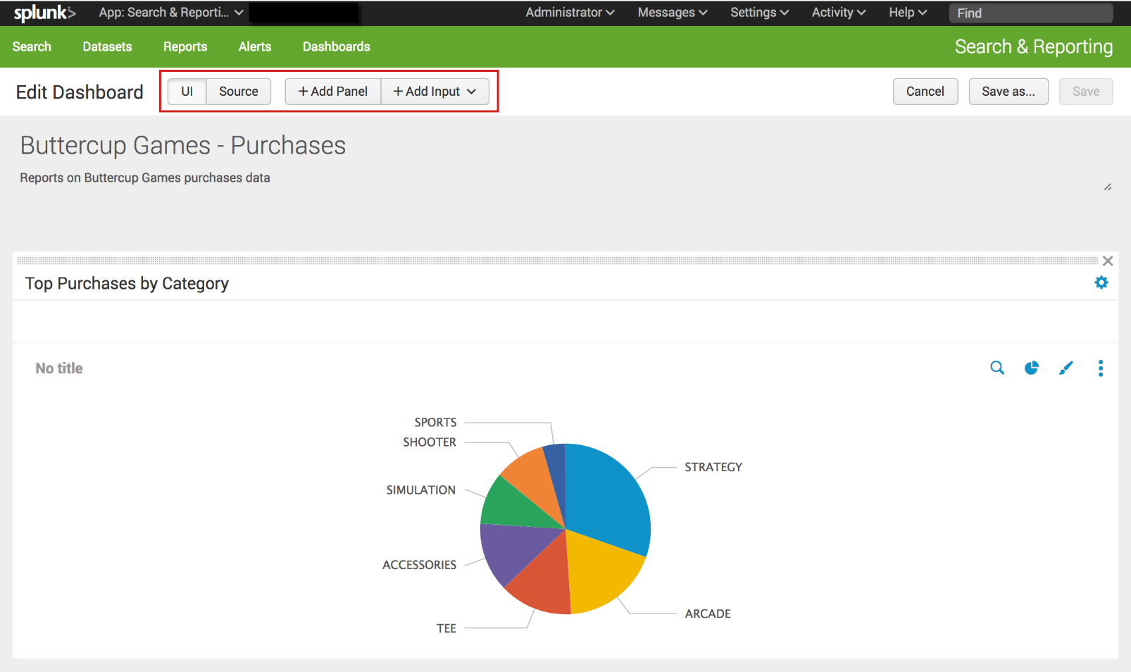](http://docs.splunk.com/File:6.6.0_tutorial_dashboards_edit.png)

1. Click **Add Input**, and select **Time**.

[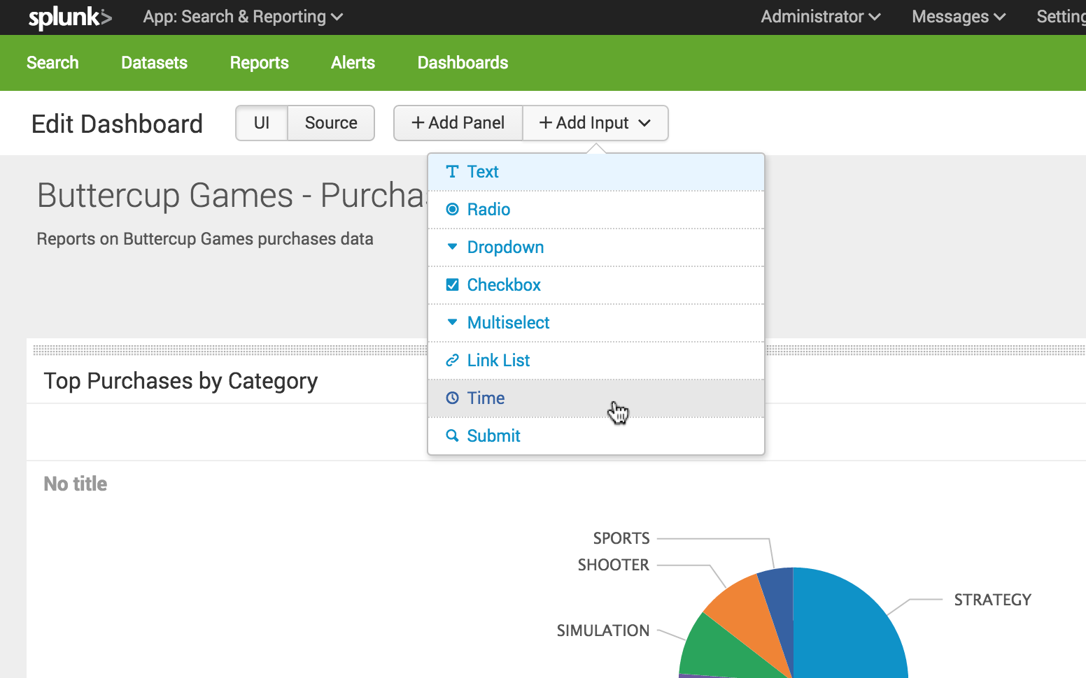](http://docs.splunk.com/File:6.5.0_tutorial_dashboards_addtimeinput.png)

The Time range picker input control appears on the dashboard.

[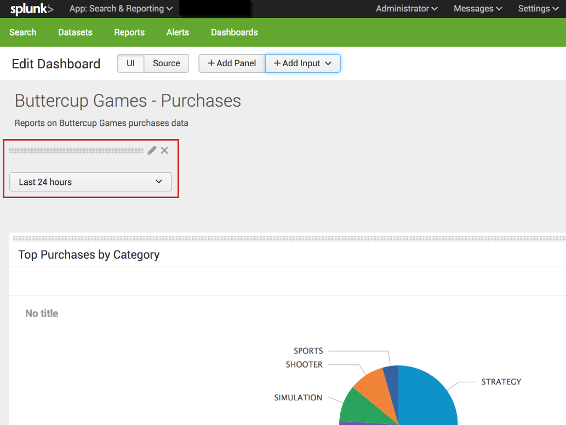](http://docs.splunk.com/File:6.6.0_tutorial_dashboards_timeinput_edit.png)

1. Click the **Edit Input** icon for the Time range picker. The icon looks like a pencil.

This opens a set of input controls. The **Time** input type is selected.

[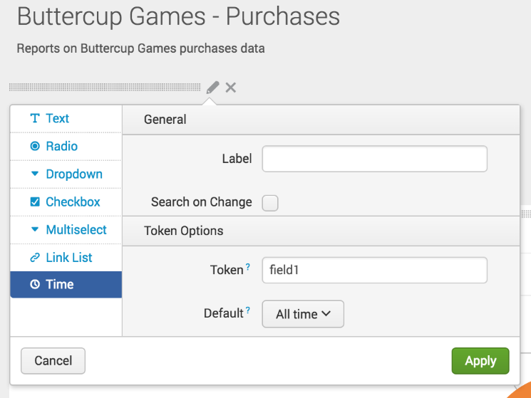](http://docs.splunk.com/File:6.5.0_tutorial_dashboards_timeinput_editoptions.png)

* 1. For **Label**, type **Time range**
  2. For **Token**, replace field 1 type **BG_Purchases_Time_Range**.

The controls that you add to a dashboard have identifiers called **input tokens**. This step redefines the name of the input token for the Time range picker. The default names for input tokens are field1, field2, field3, and so on. You can change the input tokens when you add controls to your dashboard. Naming the tokens makes it easier to understand which input you are working with. In this example you used a token name that includes the a short version of the dashboard title.

* 1. For **Default**, change the default time range to **Previous week**.
  2. Click **Apply**.

The input controls that you add to a dashboard are independent from the dashboard panels. If you want the chart on the panel to refresh when you change the time range, you need to connect the dashboard panel to the Time range picker input control.

1. In the dashboard panel, click the **Edit Search** icon.

[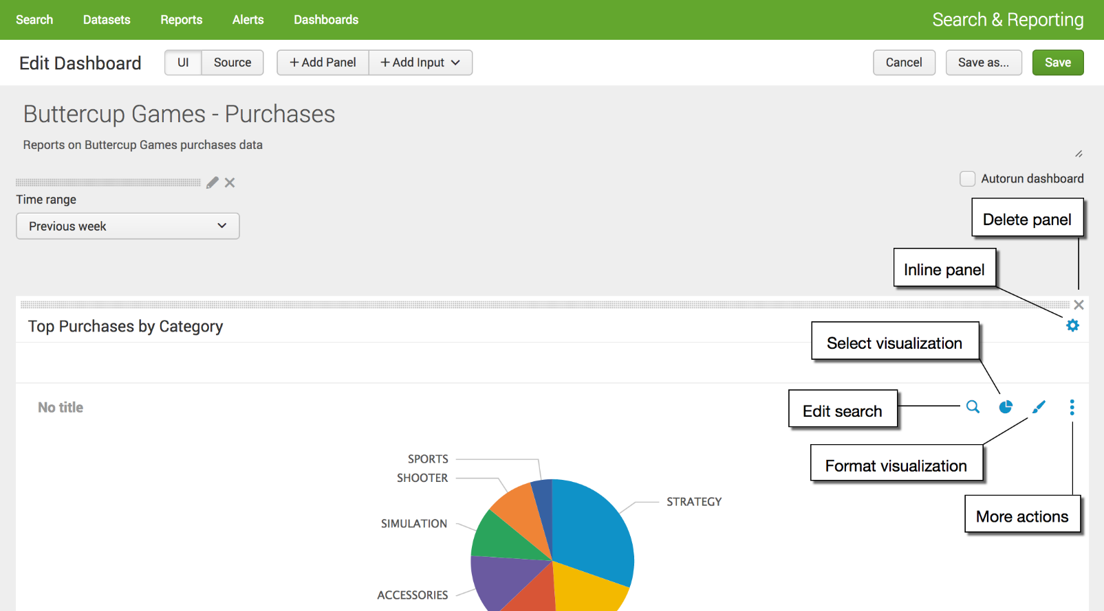](http://docs.splunk.com/File:6.6.0_tutorial_dashpanel_editsearch.png)

1. In the Edit Search dialog box, for **Time range** select **Shared Time Picker (BG_Purchases_Time_Range)**.

[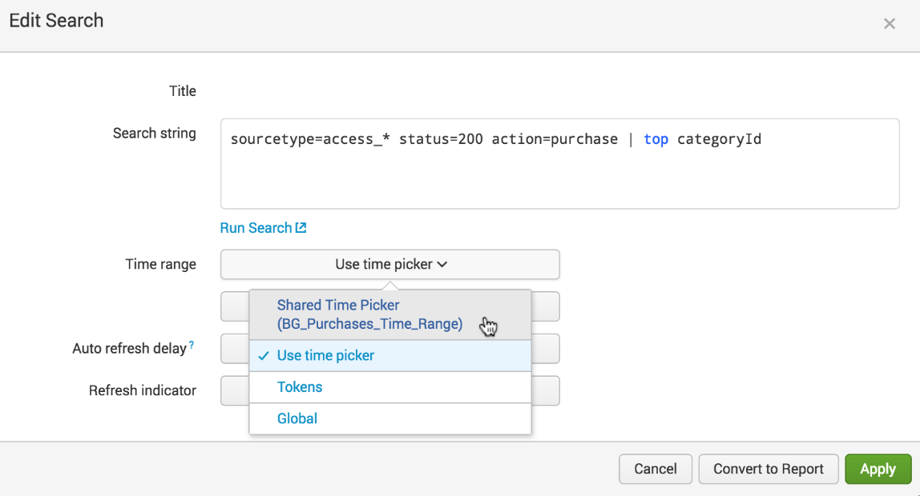](http://docs.splunk.com/File:6.6.0_tutorial_dashpanel_editsearch_edit.png)

1. Click **Apply**.
2. In the **Edit Dashboard** window, click **Save** to save the changes to the dashboard.

The panel is now connected to the Time range picker input control in the dashboard. This Time range picker is referred to as the **shared time picker**. The inline search that powers the panel now uses the time range that is specified in the shared time picker.

You can have dashboards that contain a mix of panels. Panels that are connected to the shared Time range picker, and panels that show data for the time range specified in the in the search that the panel is based on. To connect panels to the shared time picker, repeat the '''Edit Search''' steps above.

[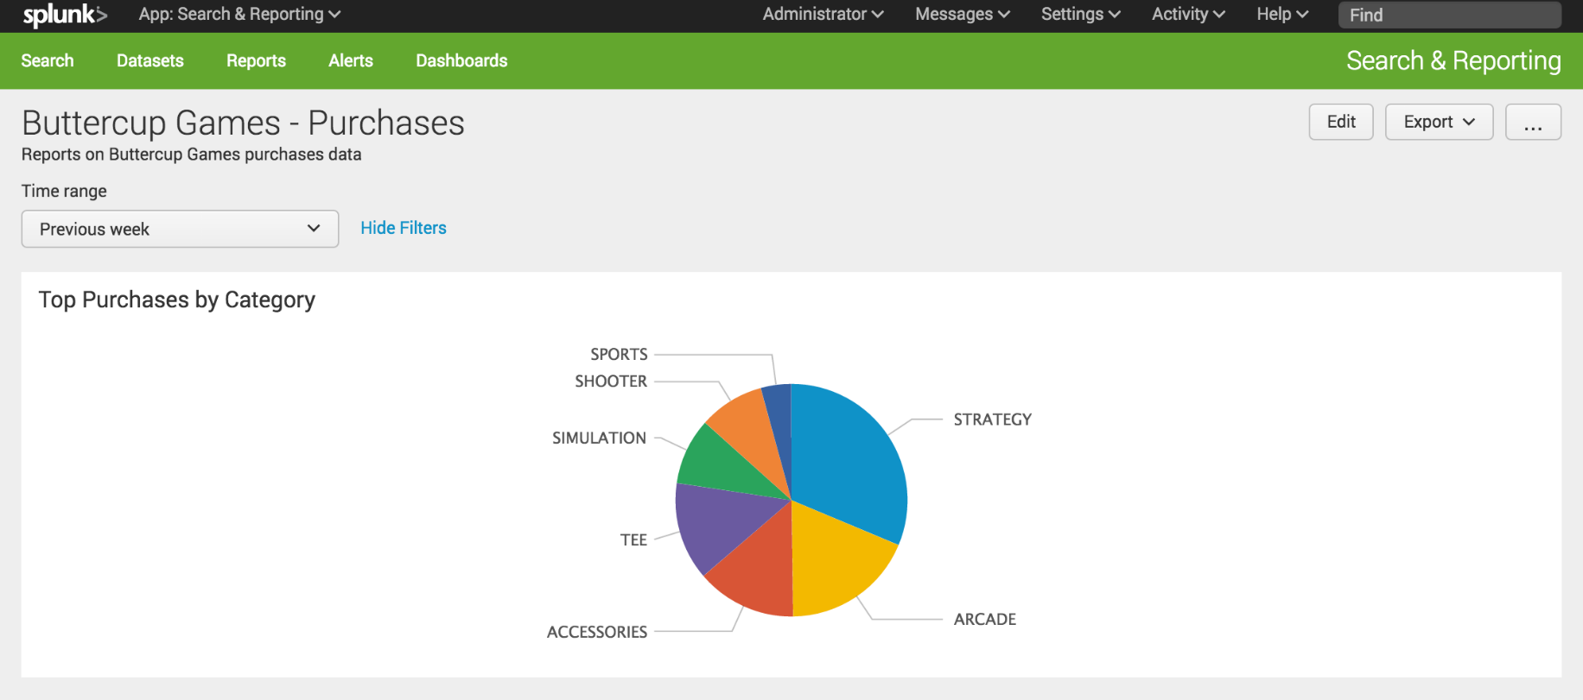](http://docs.splunk.com/File:6.5.0_tutorial_dashboardpaneledited.png)